Deborah Cobourne
English 110
Professor Schulte
27 April 2021
Patwa shud bi recognized, but nuh standardized
What’s up fi mi friend? Mi wud lakka tuh kno sinting. Mi waan kno seh, a wah duh yuh language mean tuh you? Duh ih mirror yuh rich history an culture? Duh yuh feel dat yuh cultural identity a inextricably linked tuh di language yuh taak, an tuh disregard dat wud be denouncing yuh heritage? Translation: Hello my friend! I would like to know something. What does your language mean to you? Does it mirror your rich history and culture? Do you feel that your cultural identity is inextricably linked to the language you speak, and to disregard that would be denouncing your heritage? The debate on whether Jamaican Creole – commonly known as Patois – should be treated with the same recognition and dignity as Jamaican Standard English (JSE) has been occurring for decades. Many yardies (Jamaicans) express the latter in my question above. This research paper will explore both sides of the argument and deepen your understanding of this unanswered question. Before mi guh any further let mi tek yuh inna di history addi language ah jamrock...
The transatlantic slave trade is responsible for introducing enslaved Africans to the Americas. The Arawaks were the original inhabitants of Jamaica. Starting in the mid-16th century, the English settlers established dominion over the island and forced the aboriginals into growing cash crops to be sold in England (BlackHistoryMonth.org). The term “Middle Passage” is used to describe the slave trade that occurred between Africa and the Caribbean. Africans were left with no choice but to adopt to the foreign tongue if they wanted to survive. Bear in mind, just because they come from the same continent, doesn’t mean they spoke the same language. Tribesmen from different clans, usually at war with each other, were jumbled together and forced to find a new mode of communication, or pidgins. Most of the vocabulary in patois has strong influence from countries like Ghana and Nigeria, according to Griots Republic. Griots Republic is an online company devoted to sharing information about black culture and travel. Their article “Ghana and Nigeria: Jamaica’s Not So Distant Relatives” explores the origins of some patois’ vocabulary in relation to Ghanian and Nigerian language (Griots Republic). “Two cultural groups in Africa that have the largest cultural contribution in Jamaica are the Igbo from Nigeria and Akan from Ghana” (O’Gilvie). The word “obeah” in patois is used to describe anything that pertains to witchcraft, similar to the word “obi” in Akans and “obiya” in Igbo (Nigeria). The Jamaican national fruit, ackee, came from the Akan tribe of Ghana who named it “aki”. Expressions like “big eye” and “red eye”, which mean greedy or jealous, come from Igbo and Akan expressions as well.
You might be thinking, “creole, pidgin, patois...what is the difference?” Well let mi explain eh tuh yuh. Pidgin is an auxiliary language that is formed when individuals of different language interact. It does not combine the grammatical structure of the two and lacks formalized grammar. It has no native speakers. It is simply a tool of communication (Languages 101). Creole is a language that has native speakers, its own vocabulary, and grammatical rules. There is also a chance that a pidgin can develop into a creole language. It is the result of combining two separate languages due to multicultural populations. It is typically learned as a first language. (Languages 101). The term patois, on the other hand, is a bit controversial and is considered a misnomer. The word comes French and translates to “rough, clumsy, or uneducated speech” (Wikipedia). It is considered nonstandard and isn’t recognized. You see how that can be a bit controversial? Using such a derogative word to describe a language with much history and culture is cementing the inferiority that is perceived in regard to this language. Linguists argue that the proper term should be Jamaican Creole.
Jamaican Creole has a creole-continuum. There is a variety to how the creole can be spoken. American linguist, William Alexander Stuart, specializes in creoles. The terms acrolect, mesolect, and basilect were proposed by him to categorize the various ways in which the creole can be spoken. Basilect is the less prestigious form of the creole, while acrolect is the most prestigious form with mesolect mediating between the two. Patois is considered the basilect having more African derivatives while JSE is the acrolect seeing that it is closest to English. The sociolinguistic features can be shown depending on who the person is and what they are speaking. Often, the basilect form is spoken by uneducated, rural people while the acrolect is spoken by educated city folks (WikiVisually). Alicia Beckford Wassink is a linguist who published an article on the attitude towards Jamaican Creole. She encapsulates the classism that arises between those who speak JC compared to JSE. “English became the language of prestige and power on the island, reflecting the social status of its users, while the emergent Creole was regarded as the fragmented language of fragmented people” (Wassink 58). Intelligence and respect are determined by the language you speak. This gives way to a system of classism and creates limitations on the individual.
According to the Cambridge Dictionary, the definition of a language “is a system of communication consisting of sounds, words, and grammar” (“Language”). Let us analyze the grammatical system of Jamaican Creole. The subject-verb agreement is slightly different. The structure is similar: a subject, verb, and object. However, the verb does not correspond with the subject as can be seen in this example here:
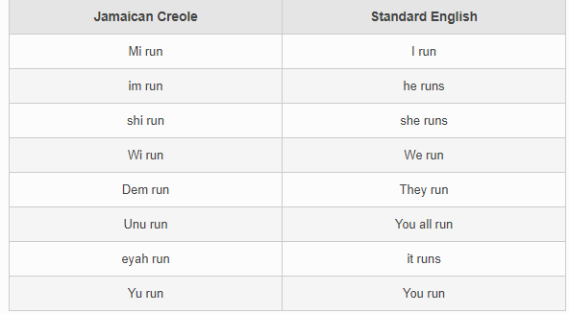
From “How to Speak Jamaican Patois." Jamaican Patwah.
Pluralization is also entirely different. In English, we use suffixes such as -s, -es, or –ies to indicate that there is more than one of something. In JC, -es or –s doesn’t denote to plurality all the time. Instead, the word “dem” is placed at the end of the word or “nuff” is placed at the beginning.
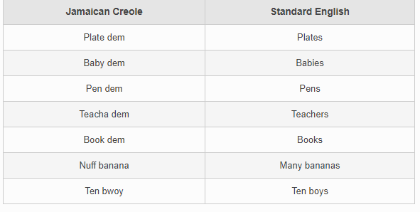
From “How to Speak Jamaican Patois." Jamaican Patwah.
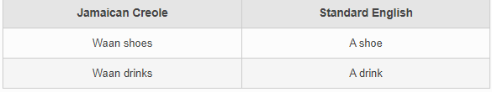
From “How to Speak Jamaican Patois." Jamaican Patwah.
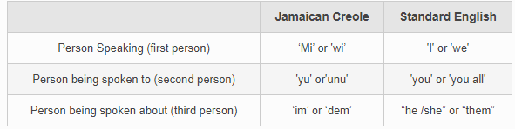
From “How to Speak Jamaican Patois." Jamaican Patwah.
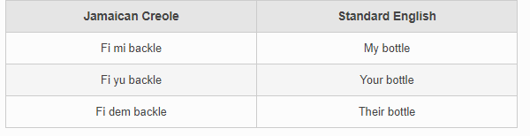
From “How to Speak Jamaican Patois." Jamaican Patwah.
A copula serves as a linking verb and is very common in JC. Repetition of a word is also used for emphasis:
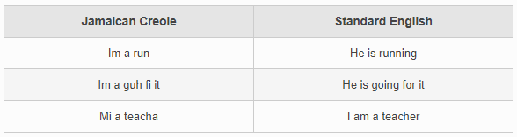
From “How to Speak Jamaican Patois." Jamaican Patwah.
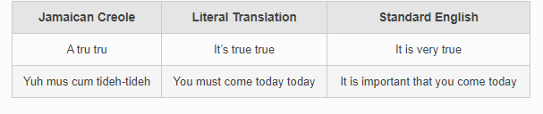
From “How to Speak Jamaican Patois." Jamaican Patwah.
Compound words are also common:
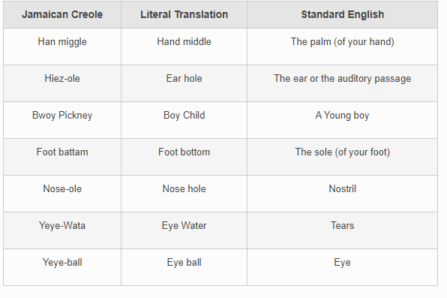
From “How to Speak Jamaican Patois." Jamaican Patwah.
Tenses are different as well. Usually in English, an “e” or “ed” is used to imply past tense. In JC, either “en”, “ben”, or “did” is used.
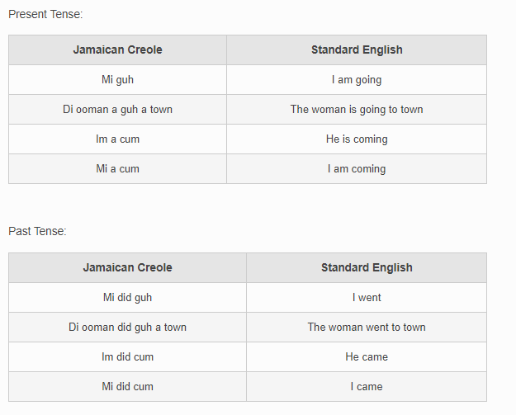
From “How to Speak Jamaican Patois." Jamaican Patwah.
We’ve examined all the reasons why JC should be recognized as a language: (1) Failure to recognize it perpetuates a system of classism. The current inferior status and misconception of the language places limitations on its user, being treated as incompetent and uneducated. This decreases the chances of social and economic mobility. (2) It has its own grammar and lexicon. Grammatical rules and sentence structure varies between JC and JSE. However, although these are valid reasons, there are many flaws in JC and standardization would not fix the underlying issues of Jamaicans’ negative perception toward the language. UK Essays is a company that provides academic support and writing services for journalist companies. In their essay, “How Patois Is Not a Language”, the writer expresses why JC is not a language. “There is no concrete spelling format designed up to this time to be associated with words spoken in Patois and there is no organized, streamlined or standardized form of communication in it” (UK Essays). In English, there aren’t various ways you can spell “school”. There is a standard to the spelling and any other variant does not imply the formation of a language, only a slang or dialect. In JC, there is a variety how you can say a word. For instance, in JSE (the acrolect) you would say “Hello”, whereas in JC you would say “Kuyaman, awara”. The mesolectal version would be “Wah gwaan mon?” The differences make it hard to establish which version is the standard. It is ever evolving.
The Gleaner Company is a newspaper-publishing enterprise that covers current events going on in the nation. It was established in 1834 and has been operating ever since. Nerissa Braimbridge published an article titled “The limitations of Jamaican patois” which discusses the marginalizing effect the creole has on its user. The author emphasizes the importance of keeping Jamaican Standard English as the official language due to Jamaican Creole having a revolving door status. Once again, many variations come and go in this creole. Even more, Braimbridge argues how knowing Standard English “affords us the ability to better understand the mechanisms of an inter-dependent world” (Braimbridge). As mentioned earlier, the common users of JC are individuals who reside in the lower socioeconomic levels. JC is the mother tongue that is spoken in the home and community. However, it is important that the younger generation comprehends JSE, because it increases their economic and social opportunities. English is recognized as the official language and is the lingua franca for international business, education, science, medicine, communication, and media. For a country whose economic stability isn’t stable and relies on relations with other countries, it is important that we keep JSE in the professional settings while JC is used at home. Bear in mind, this is not denouncing Jamaican heritage and culture. Rather, understanding the differences and impact both languages have and knowing which would be most effective to utilize depending on your setting. Jamaicans should advocate for bilingualism in the country. Giving recognition and dignity to JC will help to eliminate some of the classism and increase one‘s sense of nationality. The teaching of JSE in schools and using it in professional settings and internationally, will promote the economic status of some of its users.
Another reason why I believe JC should not be standardized (but should be recognized) is that standardization dilutes the meaning of English words. Anyone who is bilingual can tell from experience that a phrase in one language doesn’t translate perfectly into another. Whether it be that a word holds a different meaning or doesn’t exist at all, this results in using different words that can change the meaning and message behind the phrase. The BBC is a highly revered as the world’s oldest public service broadcaster circa 1922. Robert Pigott, BBC News’ religious affairs correspondent, published an article that highlighted the Bible’s translation into creole. To some it strengthens their pride and sense of identity, while others deem it as the “dilution of the word of God” (Pigott). “I don't think the Patois words can effectively communicate what the English words have communicated,” (Pigott) says Bishop Alvin Bailey of Portmore Holiness Church of God. Patois contains a lot of African derivatives that can be unintelligible to foreigners.
Patois and its failed recognition are not the problem. Essentially, Jamaicans’ negative perception towards the language is anchored in the colonization and classist system that was enforced upon them during slavery. The nation is struggling with the sense of racial inferiority due to the white-man-imposed language and educational standards. We were tricked into thinking that our language, history, and culture is second class. This ideology is mirrored in Jamaicans’ attitudes towards their fellow yaardies who are only fluent in patois. We impose limitations on our fellow brothers and sisters, further dividing us as a nation. With that being said, making Jamaican Creole the official language is similar to putting a bandage on a stab wound. The damage runs deep. Jamaican Creole is esoteric and should remain spoken in the home and community, while in professional settings we use JSE. Culturally, it is important to recognize and accept JC as a language. But to standardize it would be detrimental to the economic growth of Jamaica. Suh wah am mi saying? Wi need tuh recognize wah a inna nations bess interest as ah developing country. Jamrock a ah beautiful country wid an energetic language. Yuh can nuh remove di yaad fram di heart. Wi muss tap fighting each oddah an staat a wuk togedda tuh heal di nation an build ih up.

Work Cited
- "History of Jamaica." Black History Month 2021, 28 June 2020, www.blackhistorymonth.org.uk/article/section/jamaica/history-of jamaica/#:~:text=The%20Jamaican%20slaves%20were%20bound,and%20slave%2Dbased%20economy%20faltered. Accessed 30 Apr. 2021.
- "Ghana and Nigeria: Jamaica's not so distant relatives." Griots Republic, 6 Sept. 2018, www.griotsrepublic.com/ghana-nigeria-jamaicas-not-distant-relatives/
- "Languages 101: Creoles, Pidgins, and Patois." Polyglossic, 24 May 2012, polyglossic.wordpress.com/2012/05/24/languages-101-creoles-pidgins-and-patois/.
- Wikipedia. "Patois." Wikipedia, the Free Encyclopedia, Wikimedia Foundation, Inc, 1. Dec. 2002, en.wikipedia.org/wiki/Patois#:~:text=The%20word%20assumes%20the%20view,offensive%20when%20used%20by%20outsiders.&text=The%20vernacular%20form%20of%20English,to%20Jamaican%20Patois%20from%201934. Accessed 30 Apr. 2021.
- WikiVisually. "WikiVisually.com." The Entire Wiki with Photo and Video Galleries - WikiVisually, wikivisually.com/wiki/Post-creole_continuum. Accessed 30 Apr. 2021.
- "LANGUAGE | Definition in the Cambridge English Dictionary." Cambridge Dictionary | English Dictionary, Translations & Thesaurus, dictionary.cambridge.org/us/dictionary/english/language.
- "How to Speak Jamaican Patois." Jamaican Patwah, 22 June 2013, jamaicanpatwah.com/b/how-to-speak-jamaican-patois#.YIsXPO2SmUm.
- "How Patois Is Not A Language English Language Essay." UKEssays. ukessays.com, November 2018. Web. 30 April 2021. <https://www.ukessays.com/essays/english-language/how-patois-is-not-a-language-english-language-essay.php?vref=1>.
- "The Limitations of Jamaican Patois." Jamaica Gleaner, 18 July 2010, jamaica-gleaner.com/gleaner/20100718/cleisure/cleisure5.html. Accessed 30 Apr. 2021.
- Pigott, Robert. "Jamaica's Patois Bible: The Word of God in Creole." BBC News, 25 Dec. 2011, www.bbc.com/news/magazine-16285462. Accessed 30 Apr. 2021.
- Wassink, Alicia B. "Historic Low Prestige and Seeds of Change: Attitudes toward Jamaican Creole." Database Menu, Mar. 1999, Accessed 29 Apr. 2021.

"Ghana and Nigeria: Jamaica's not so distant relatives." Griots Republic, 6 Sept. 2018, www.griotsrepublic.com/ghana-nigeria-jamaicas-not-distant-relatives/.
"Languages 101: Creoles, Pidgins, and Patois." Polyglossic, 24 May 2012, polyglossic.wordpress.com/2012/05/24/languages-101-creoles-pidgins-and-patois/.
Wassink, Alicia B. "Historic Low Prestige and Seeds of Change: Attitudes toward Jamaican Creole." Database Menu, Mar. 1999, Accessed 29 Apr. 2021.
"LANGUAGE | Definition in the Cambridge English Dictionary." Cambridge Dictionary | English Dictionary, Translations & Thesaurus, dictionary.cambridge.org/us/dictionary/english/language.
"How to Speak Jamaican Patois." Jamaican Patwah, 22 June 2013, jamaicanpatwah.com/b/how-to-speak-jamaican-patois#.YIsXPO2SmUm.
"How Patois Is Not A Language English Language Essay." UKEssays. ukessays.com, November 2018. Web. 30 April 2021. <https://www.ukessays.com/essays/english-language/how-patois-is-not-a-language-english-language-essay.php?vref=1>.
"The Limitations of Jamaican Patois." Jamaica Gleaner, 18 July 2010, jamaica-gleaner.com/gleaner/20100718/cleisure/cleisure5.html. Accessed 30 Apr. 2021.
Pigott, Robert. "Jamaica's Patois Bible: The Word of God in Creole." BBC News, 25 Dec. 2011, www.bbc.com/news/magazine-16285462.
"History of Jamaica." Black History Month 2021, 28 June 2020, www.blackhistorymonth.org.uk/article/section/jamaica/history-of-jamaica/#:~:text=The%20Jamaican%20slaves%20were%20bound,and%20slave%2Dbased%20economy%20faltered. Accessed 30 Apr. 2021.
Wikipedia. "Patois." Wikipedia, the Free Encyclopedia, Wikimedia Foundation, Inc, 1 Dec. 2002, en.wikipedia.org/wiki/Patois#:~:text=The%20word%20assumes%20the%20view,offensive%20when%20used%20by%20outsiders.&text=The%20vernacular%20form%20of%20English,to%20Jamaican%20Patois%20from%201934. Accessed 30 Apr. 2021.
WikiVisually. "WikiVisually.com." The Entire Wiki with Photo and Video Galleries - WikiVisually, wikivisually.com/wiki/Post-creole_continuum. Accessed 30 Apr. 2021.

